# Bilal Ahmed (4th Sem) B19102029 (DSA) Lab #01

**Q1. Your task is to design two different algorithms in Python/C++ which calculates the factorial of a number entered by the user.**

(you may choose iterative and recursive approach)

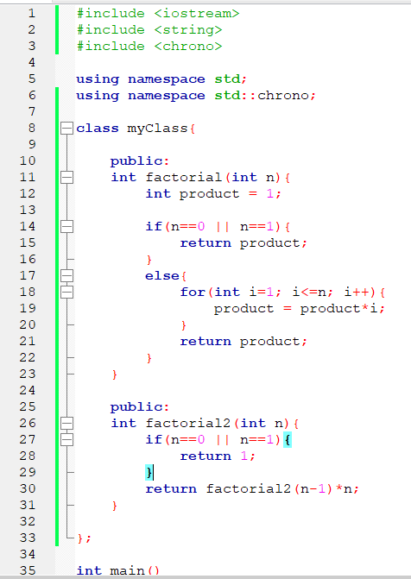  
  
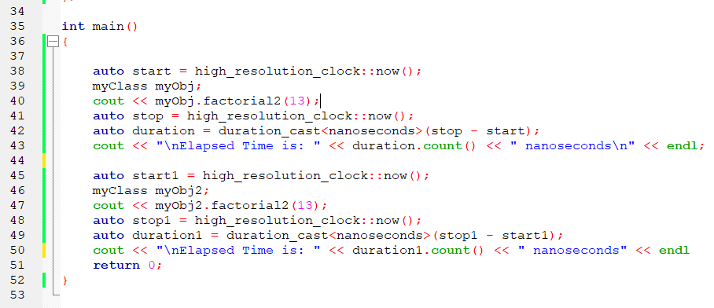

**Q2. Compare the performance of the above two algorithms by finding the time required to execute the algorithms (you can use %timeit)**

|  |  |  |
| --- | --- | --- |
| **Input number (int n)** | **First approach (Loop)**  **Time (nanoseconds)** | **Second approach (Recursion) Time (nano seconds)** |
| **5** |  |  |
| **11** |  |  |
| **26** |  |  |
| **33** |  |  |